Graphing Homework

Directions: Identify the key features of each of the graphs given.
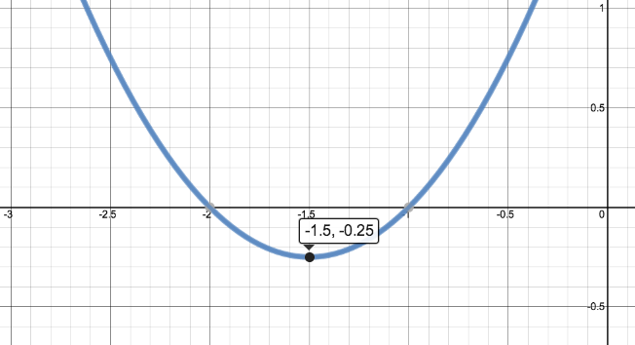
1. a. Function Type: _____________________

b. Domain: _______________________________

c. Range: _________________________________

d. Min/Max: _____________________________

e. Increasing: ____________________________

f. Decreasing: ___________________________

g. Zeros: _________________________________

h. Continuity: ____________________________

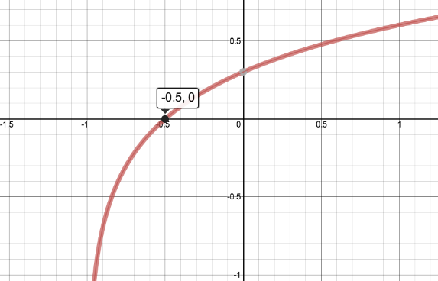
2. a. Function Type: _____________________

b. Domain: _______________________________

c. Range: _________________________________

d. Min/Max: _____________________________

e. Increasing: ____________________________

f. Decreasing: ___________________________

g. Zeros: _________________________________

h. Continuity: ____________________________

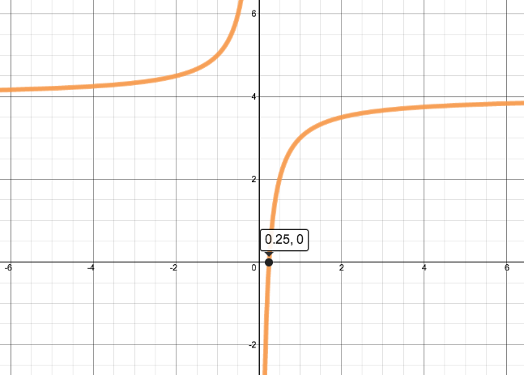
3. a. Function Type: _____________________

b. Domain: _______________________________

c. Range: _________________________________

d. Min/Max: _____________________________

e. Increasing: ____________________________

f. Decreasing: ___________________________

g. Zeros: _________________________________

h. Continuity: ____________________________

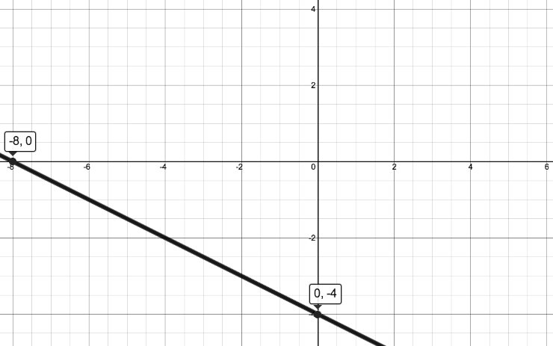
4. a. Function Type: _____________________

b. Domain: _______________________________

c. Range: _________________________________

d. Min/Max: _____________________________

e. Increasing: ____________________________

f. Decreasing: ___________________________

g. Zeros: _________________________________

h. Continuity: ____________________________

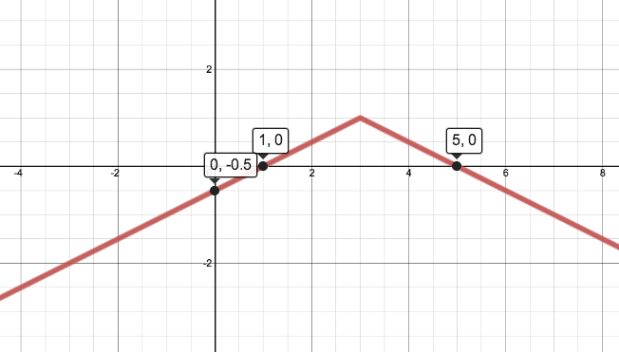
5. a. Function Type: _____________________

b. Domain: _______________________________

c. Range: _________________________________

d. Min/Max: _____________________________

e. Increasing: ____________________________

f. Decreasing: ___________________________

g. Zeros: _________________________________

h. Continuity: ____________________________

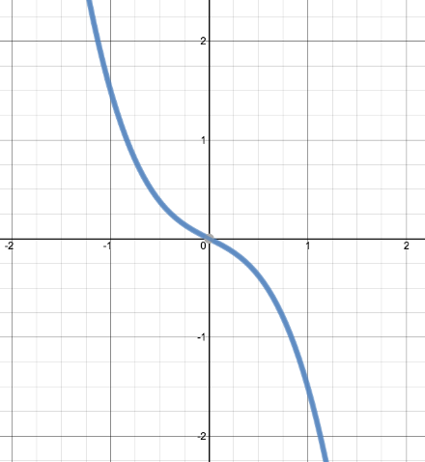

6. a. Function Type: _____________________

b. Domain: _______________________________

c. Range: _________________________________

d. Min/Max: _____________________________

e. Increasing: ____________________________

f. Decreasing: ___________________________

g. Zeros: _________________________________

h. Continuity: ____________________________

